Cookies & Cream Fudge, 7 Oz.
Vanilla fudge with Oreo cookies

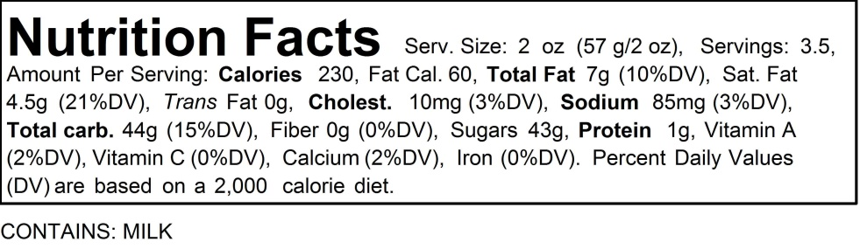
Ingredients: Sugar, cocoa butter, cream, Oreos(enriched flour, sugar, high oleic canola oil, cocoa, high fructose corn syrup, leavening, cornstarch, salt, soy lecithin, vanilla, chocolate), white chocolate(sugar, cocoa butter, milk, nonfat dry milk, soy lecithin, vanilla), butter(cream, salt), corn syrup, potassium sorbate(preservative), salt, vanilla(water, vanillin, caramel color, ethyl vanillin, citric acid, sodium benzoate), natural & artificial flavoring.

Zero Trans Fat – High Fructose Corn Syrup, Gluten

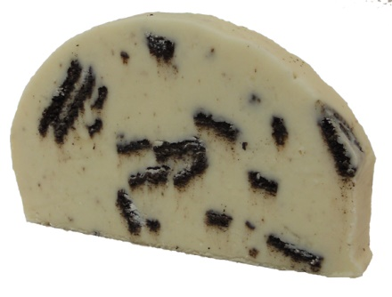
Wrapped:
Boxed:

